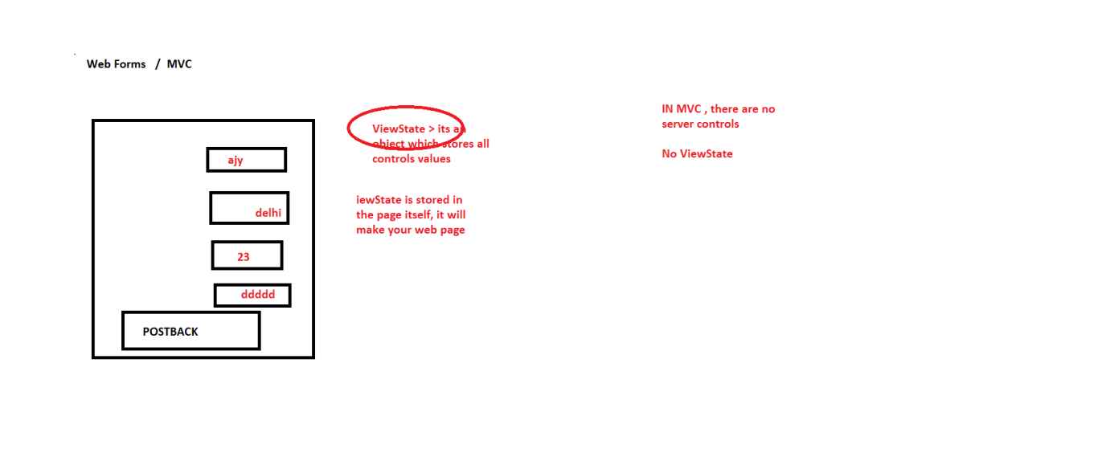

Limitations in Web Forms

Web Forms

They are heavy > Because of server controls , viewstate

There is no separation of concerns

When we make any applications , how many component are there

Front End (UI) > user will interact with the application from here

Business Layer (BL) This layer will come in between FE & BE

Data base Layer (DL) > Interacting with Database

If my application is very small, we can keep all these components on a single system

Keep these components in different machines

Single – tier applications

2 –tier applications

3 – tier application

N-tier application

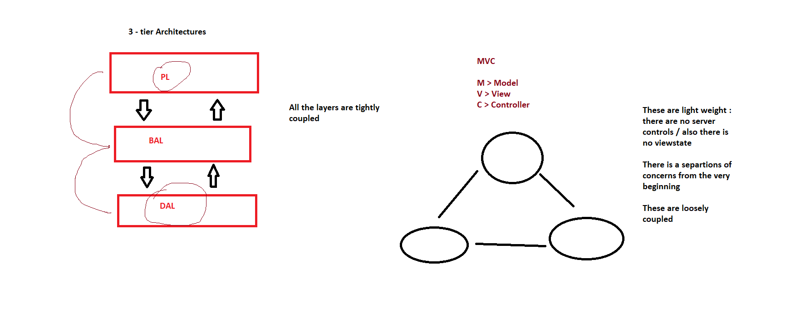

MVC >

Controller > Controller is responsible for handling user request. Whenever the request from the browser, it will be handled by controller

In Controller, we have action methods, which can return view

View> They are .cshtml / .vbhtml pages , they are used to interact with the user

Model > Represents your domain, all your classes will come here

Example >

Routes decide that >

Controller> Manager > Redirects users to respective areas (action method)

View > Waiter , who will bring menu to user, food to user, bill to user

Cook > Model > who actually prepares food

Controller >

Model

View